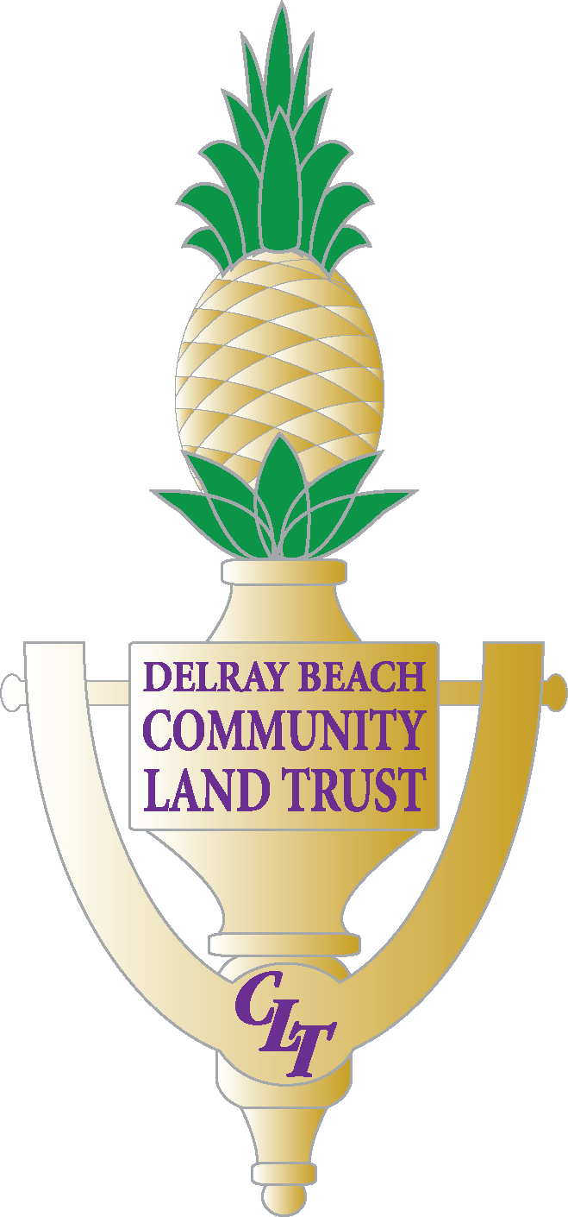

The form must be submitted with the requested information and must be received no later than August 31st, 2022. If you have any questions or concerns please feel free to contact our office by Phone at 561-243-7500 or by Email - edmond@mydelraybeach.com or dobson@mydelraybeach.com
Last Name: |  | First Name: |  |  | M.I.
Occupation/Job Title:

Home Address: | City: |  |  | State: | Zip Code:
Legal Residence: | City: |  |  | State:
Principal Business Address: | City: |  |  | State: | Zip Code:
Home Phone: |  | Work Phone: | Fax Phone:
Email: |  |  | Date of Birth:
Are you currently a Board Member? __________yes _________no

Are you a former Board Member of the DBCLT? __________yes _________no

Have you ever attended a DBCLT meeting? __________yes _________no

Are you a Delray Beach Community Land Trust home owner? __________yes _________no
- Have you had any business relations directly or indirectly with the DBCLT for services that may preclude you from being considered as a board member?

- Briefly describe why you would like to serve on the Delray Beach Community Land Trust Board (attached a separate sheet if necessary):

- List any and all Boards on which you currently or have previously served: (Please indicate dates if possible)

- In line with the role and responsibilities of a board member (attached), how may your educational or professional background compliment your commitment as a board member of the Delray Beach Community Land Trust?

- Are you familiar with the Delray Beach Community Land Trust’s mission and goals?

- Please attach a brief BIO or Resume

____________________________________ __________________________
SIGNATURE DATE

